

**WEB APP DEVELOPMENT**

**BSCS-4**

**Lab 11**

**Name:** Eshal Siraj

**Sap ID:** 54686

**Submitted to:** Mam Nayab Khalid

**TASK 1: GET METHOD**

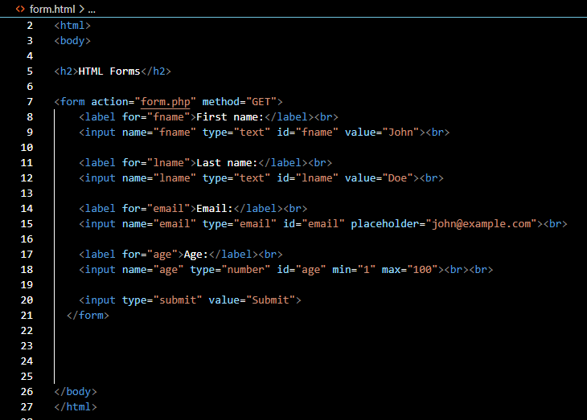

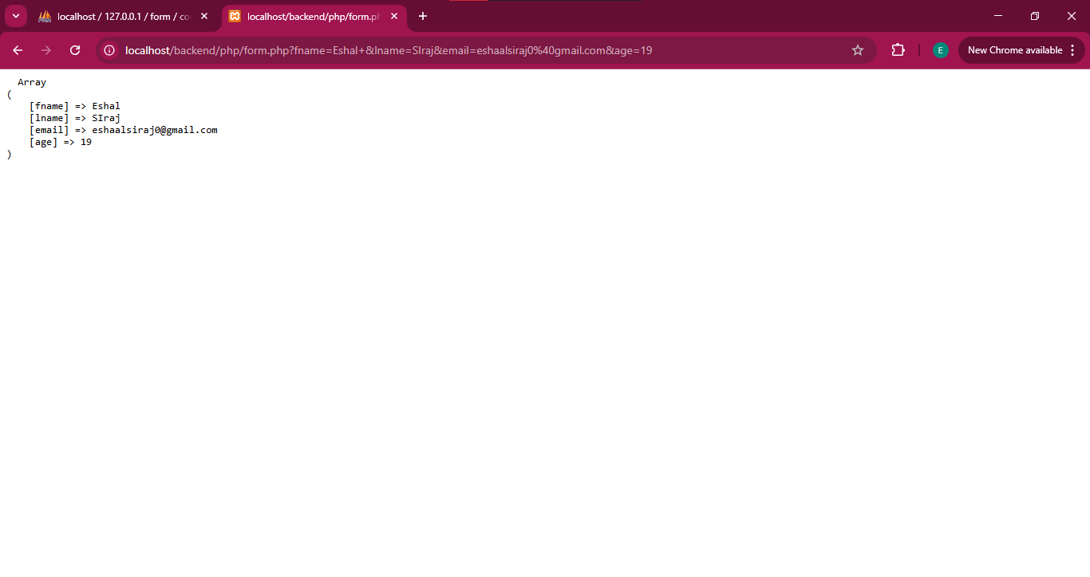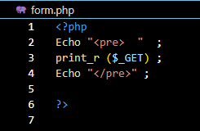

**TASK 2: POST METHOD**

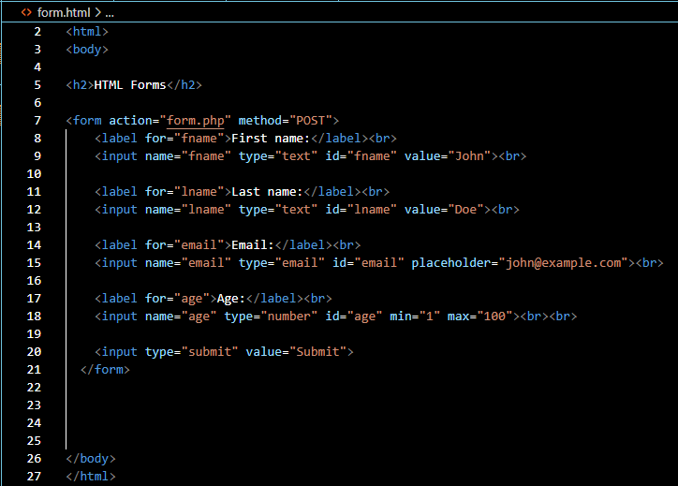

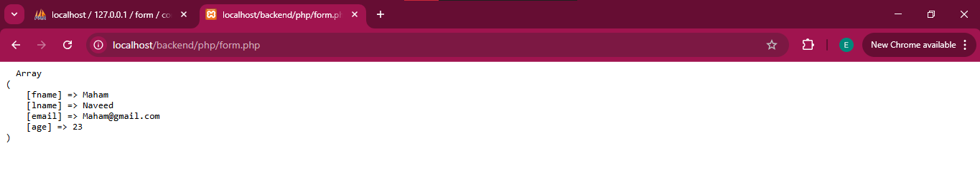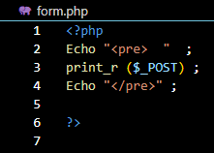

**TASK 3: REQUEST METHOD**

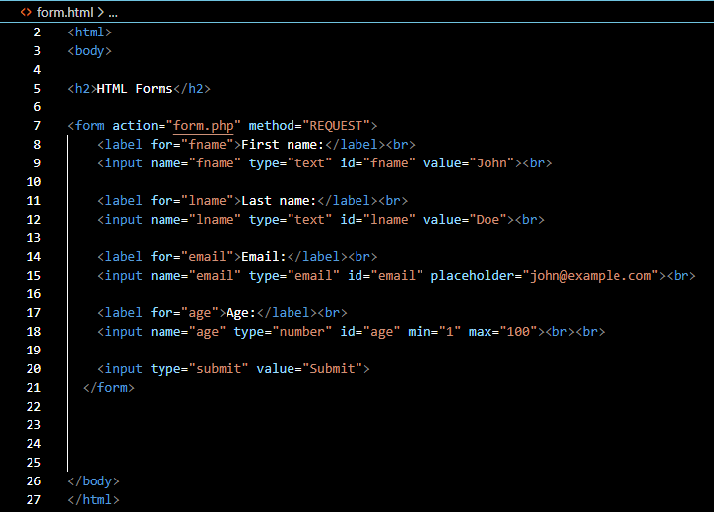

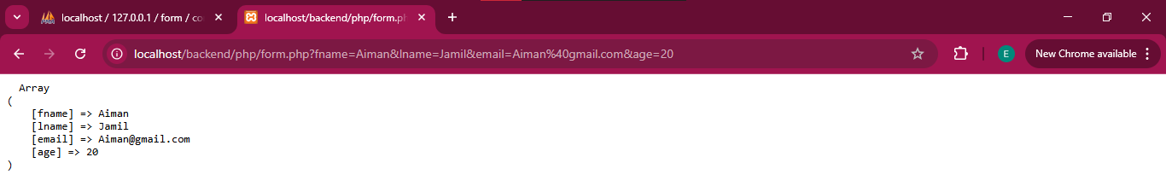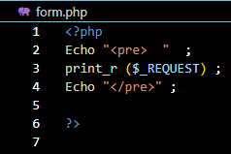

**TASK 4: DIFFERENCE BETWEEN GET AND POST METHOD**

**GET METHOD:**

**POST METHOD:**

TASK 5: CONNECTION WITH SQL USING PHP

